UNIT -2
S. Varsha Reddy(192572177)
CSA1006-SOFTWARE ENGINEERING

Problem 3:
Choosing Architecture for a Scalable Food Delivery Platform
Scenario
A startup wants to build a food delivery platform similar to Swiggy or Zomato that can handle thousands of orders during peak hours. The CTO must choose between Monolithic, Microservices, and Serverless architectures.

1. Recommended Architecture Choice
Recommended Architecture: Microservices Architecture
Justification
A food delivery platform consists of multiple independent functionalities such as user management, restaurant management, order processing, payment, delivery tracking, and notifications.
In a Microservices Architecture, each functionality is developed as an independent service. These services communicate through APIs or events, allowing each service to scale, update, and recover independently.
This architecture is ideal for applications that receive thousands of requests per minute because it provides:
- High scalability
- Better reliability
- Independent deployment
- Easier maintenance

2. Three Technical Reasons for Choosing Microservices
1. High Scalability
During lunch and dinner hours, order traffic increases significantly.
With Microservices:
- Only the Order Service can be scaled.
- Payment and Delivery services remain unchanged.
- Infrastructure resources are used efficiently.
Example:
If 20,000 users place orders simultaneously, additional instances of the Order Service can be added without affecting other services.

2. Independent Deployment
Each service can be developed, tested, and deployed separately.
For example:
- Payment team updates the Payment Service.
- Delivery team updates the Delivery Service.
These updates do not interrupt the complete application.
Benefits
- Faster software releases
- Reduced downtime
- Easier maintenance

3. Better Fault Isolation
If one service fails, the remaining services continue to operate.
Example
If the Payment Service crashes:
- Customers can still browse restaurants.
- Users can add items to the cart.
- Delivery tracking remains available.
This improves the overall reliability of the platform.

Task3. Role of Event-Driven Architecture
What is Event-Driven Architecture?
Event-Driven Architecture is a communication model where services communicate by publishing and subscribing to events instead of directly calling one another.
A message broker such as Kafka or RabbitMQ delivers events between services.
Benefits of Event-Driven Architecture
1. Faster Processing
Multiple services process the same event simultaneously.
2. Loose Coupling
Services are independent and do not rely directly on each other.
3. Easy Scalability
Each service can scale independently based on workload.
4. Real-Time Updates
Customers receive instant notifications about payment status, order confirmation, and delivery tracking.

4. Suitable Microservices
Microservice | Responsibilities
Order Service | Accepts customer orders, validates items, calculates bill, stores order information
Payment Service | Processes online payments, verifies transactions, generates payment receipts
Delivery Service | Assigns delivery partners, tracks delivery location, updates delivery status

Architecture Diagram
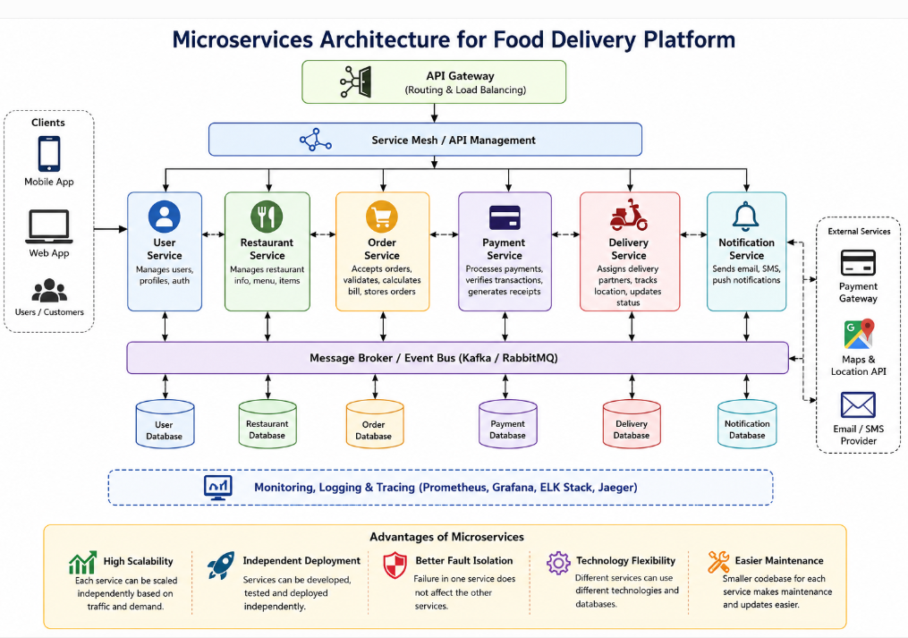

Advantages of Microservices
- High scalability
- Independent deployment
- Better fault isolation
- Easy maintenance
- Faster development
- Supports cloud deployment
- Improved system performance
- High reliability

Conclusion
For a scalable food delivery platform like Swiggy or Zomato, Microservices Architecture is the best choice because it provides high scalability, independent deployment, fault isolation, and easier maintenance. When combined with Event-Driven Architecture, services communicate efficiently through events, enabling real-time updates and the ability to process thousands of orders simultaneously. Using dedicated microservices such as Order Service, Payment Service, and Delivery Service makes the platform reliable, flexible, and capable of handling peak-hour traffic effectively.

